**Enemies Among Us**

**by Bettina Petersen**

There is a reason so many of us have decided to call Florida home. The warm, sunny weather is ideally suited for us to thrive and flourish. Unfortunately, this hospitable climate is not without its drawbacks. The delicate ecosystem that this beautiful Florida climate supports is susceptible to invaders that also thrive in this climate. And if we’re not careful the plants and animals that are native to Florida could disappear.

Florida is currently in the midst of an invasive species crisis that could unrepairable damage to the entire ecosystem. What is an invasive species? An invasive species is one that is introduced into an ecosystem where it is not naturally occurring. If the conditions are right, that species can outcompete native species for resources and potentially drive it to extinction. And if a species does go extinct, the entire ecosystem it inhabited will be impacted.

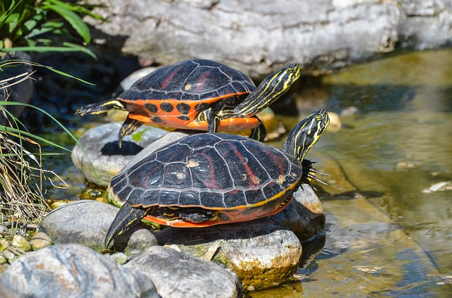

For example, a species of plant that is kept in check in its native ecosystem may not have the same competition for resources in the ecosystem that it is introduced to. When growth is supported in this way the species can aggressively take over. And this could spell both environmental and economic disaster.

Many may be surprised to discover that Florida’s Green Iguana population is not native to the peninsula. Because of this, the lizard’s ravenous vegetarian appetite has had a major impact on Florida’s fruit industry. This problem is exacerbated when people treat these wild animals like backyard pets—creating even more favorable conditions for them.

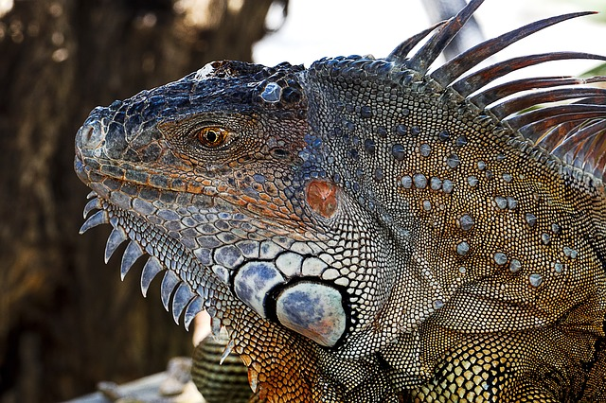

So, what can people do to help the Florida ecosystem? There are many steps that residents can take to prevent the introduction and spread of invasive species into the ecosystem. One step, as outlined by Sarah Ricci (2013), involves being more aware of what we introduce to our local environments.

Article about invasive species. Article about invasive species. Article about invasive species.